BALLOON-POWERED CAR
Time: 60 minutes

Materials
Scissors (optional) | Ruler | Masking tape | Small plastic stirrer straws | Sharp pencil | Meter Stick or metric measuring tap

For Group
3 per group | Balloon | Cardboard base | 2 paper/styrofoam plates

Getting Started
- In this activity, students will investigate Newton’s third law of motion by designing and constructing rocket-powered racing cars. In addition, they will experiment with ways of increasing the distance the rocket car travels.
- Students will construct racing cars and power them with the thrust of an inflated balloon. In three racing trials, the racers shoot along a straight course, and the distance the racers travel is measured. Between trials, students will redesign their racers to improve their performance and solve any “mechanical” problems that come up. At the end of the activity, students will submit a detailed report on their racer design and how it performed in the trials.

Directions

Building: Wheel Patterns
- Cut out the desired wheel size. Trace the wheel outline on the Styrofoam. Punch the pencil point through the cross to mark the center.
Building: Rocket Racer
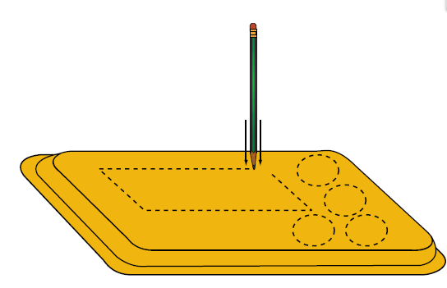
- Lay out your pattern on the Styrofoam tray. You will need a racer body and wheels. Use a pencil point to score the Styrofoam. Snap out your pieces and smooth them. Make sure your wheels are round! Use sandpaper to round the wheels OR press them on a hard surface and roll them.

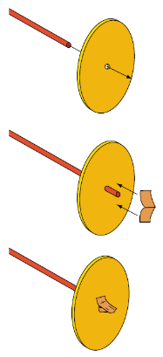
- Punch a small hole in the center of each wheel with the pencil. Push the axle (stirrer) straw through the hole of one wheel so that it extends 1 cm on the other side. Pinch a piece of masking tape around the end of the straw and smooth it on to the wheel. Do the same for the second axle. Do not add wheels to the other ends yet!

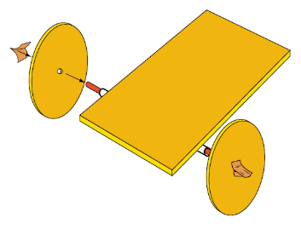
- Cut two large straws to the size you want. Tape them parallel to each other on the bottom of the racer body at opposite ends. Slide a wheel and axel through one of the straws and mount a second wheel on the other end of the axle.
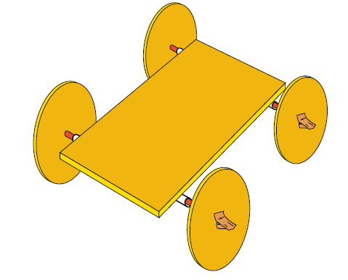
- Slide the second wheel and axle through the remaining straw and mount the remaining wheel at its opposite end.

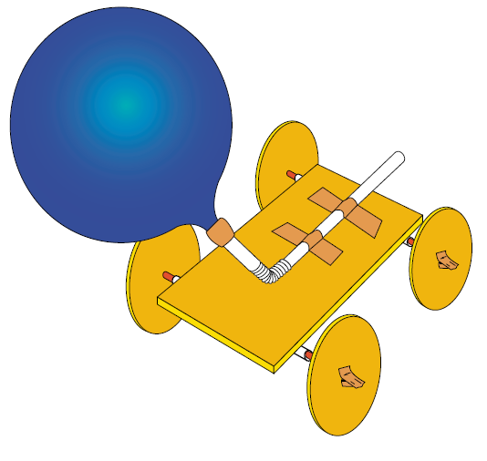
- Blow up the balloon and then let the air out. Next, slip the straw into the balloon as shown. Use masking tape to seal the balloon nozzle to the straw. Squeeze the tape tightly to seal all holes. Test the seal by blowing up the balloon again through the straw.

- Mount the balloon and straw to the racer with masking tape as shown. Be sure the end of the straw (rocket nozzle) extends off the end of the racer body.

Analyzing:
- Air is compressed inside the balloon that is expanded. When the nozzle is released, the balloon returns to its original un-inflated size by propelling the air out of its nozzle. The action force of the expelling air produces a reaction force that pushes the racer in the opposite direction.
- The racer’s wheels reduce friction with the floor, and the racer takes off down the race course.
- The engineering design of the racer is very important. In principle (Newton’s second law of motion), the less mass the car has, the greater its acceleration will be. Generally, heavy rocket racers do less well than lighter racers.
- However, very small racers are limited by other factors. Vehicles with short wheel bases tend to circle or partially life off the floor. Balance becomes a problem. The mass of the balloon may cause the car to tilt nose down to the floor, causing a poor start. Many designs are possible, including wide, narrow, and I-Beam shaped bodies and three, four or even six wheels.
- Because of individual variations in the student’s cars, they will travel different distances and often in unplanned directions. Through modifications, the students can correct for undesirable results and improve their cars’ efficiency. They will have to review the trade-offs of their design. For example, an extra-long body may provide a straighter path, but the car might travel a shorter distance as a result.

